# GIS & LAND CHANGE MODELS 2022 Exam

Save this file with your CLARKU userid in the file name, then post to Moodle by 10pm Monday 21 November 2022. You must work alone so that your responses reflect your own work. You may use your class notes, the materials on Moodle, and the internet. You are not allowed to consult with other present or former students.

This exam has two sections: Multiple-Choice and Essay. The Multiple-Choice section is worth 70% of the exam grade. The Essay section is worth 30% of the exam grade.

Multiple-Choice

Highlight in yellow the best single choice for each question. Each question is worth 2% of the exam grade.

1. What is the difference between a pattern and a process?

1. A process describes the data, while a pattern describes the mechanisms that create the process.
2. A pattern describes the data, while a process describes the mechanisms that create the pattern.
3. A process describes the physics of an event, while a pattern describes human influence on an event.
4. A pattern describes the physics of an event, while a process describes human influence on an event.

2. What is a scenario in landscape modelling?

1. A prediction of what will occur.
2. A process-based extrapolation.
3. A pattern-based extrapolation.
4. A story told in words, numbers and maps concerning a possible way the future could be.

3. Identify an example of land use.

1. Agriculture
2. Deciduous Forest
3. Grassland
4. All of the above

4. Which of the following is an example of a land cover:

1. Agriculture
2. Hunting
3. Forest
4. Transportation

5. Interpolation then subsequent extrapolation of the pattern illustrates

1. validation of the data
2. a method to make a recent trends scenario
3. process stationarity
4. non-stationarity

6. We perform pattern validation because

1. we must show that the model predicts accurately
2. we want to measure how the simulation differs from reality
3. we want to test whether the model behaves as the programmer intends
4. a model gives useful insight only when the model predicts accurately

7. What does verification test?

1. Whether the simulation has predictive power
2. How the variation of the inputs influences the variation of the model’s simulation
3. Whether the model is valid
4. Whether the model behaves as the documentation advertises

8. How can you tell whether a pattern is stationary through time?

1. By seeing whether the calibration data lies on a straight trendline
2. By interviewing agents of change
3. By seeing whether the data’s trend during one time interval is consistent with the data’s trend during other time intervals.
4. By seeing whether business during the first time interval is consistent with business during the second time interval

9. Which of these models illustrates the use of a deductive model?

1. Forest loss has been near built during the recent 10 years, therefore we simulate forest loss will be near built during the next 10 years.
2. We use the contiguity rule in GEOMOD because we have a theory that humans will build near where people previously built.
3. The Multi-Layer Perceptron in TerrSet’s Land Change Modeler.
4. Logistic Regression in TerrSet’s Land Change Modeler.

10. How does Geomod differ from the Land Change Modeler (LCM)?

1. Geomod is inductive while LCM is deductive.
2. Geomod can calibrate with a land-use map at one time point where LCM requires two time points for calibration.
3. Geomod calibrates with a land-use map at one time point where LCM allows calibration at either one or two time points.
4. It is possible to modify the quantity simulated in Geomod but not in LCM

10. If Misses equal False Alarms during validation, then …

1. The simulation had the correct quantity.
2. The model performed well.
3. Hits are greater than error.
4. Hits are equal to Correct Rejections.

11. The TOC curve below concerning the validation of a simulation model indicates …

1. Some patterns are non-stationarity from the calibration to the validation interval.
2. The model has zero false alarms when the model uses the correct quantity.
3. The simulation performed poorly.
4. The reference change during the validation interval is greater than half of the candidates for change at the start of the validation interval.

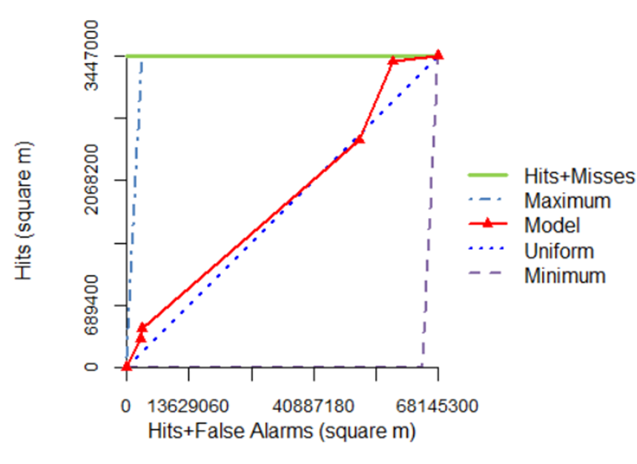

12. The Markov Matrix …

1. has a sum of 1 down each of its columns.
2. relates to a time interval of a particular duration.
3. is the part of LCM that influences the spatial allocation of change.
4. controls the quantity of simulated change in both Geomod and LCM.

13. The Multi-Layer Perceptron neural net …

1. produces a mathematical relationship that a logistic equation describes.
2. can produce outputs that vary among runs that have the same inputs.
3. produces output where larger transition potentials imply more simulated change.
4. depends on the duration of the extrapolation time interval.

14. When a mathematical relationship is overfit ...

1. it is specific to a great level of detail that is not important to the purpose.
2. it lacks sufficient detail to express patterns that are important to the extrapolation.
3. it expresses patterns in sufficient detail without being too specific to the calibration.
4. None of the above

15. What is a dynamic variable?

1. A variable that is weighted greater than 0.5.
2. A variable that is weighted less than 0.5.
3. A variable that is consistent through time.
4. A variable that changes through time.

16. Application of a Markov matrix through equal time intervals tends to make the sizes of changes during sequential time intervals ...

1. eventually accelerate.
2. eventually decelerate.
3. become undefined.
4. become negative.

17. What is the value of X in the Markov matrix below?

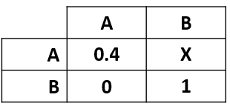

1. 0.0
2. 0.4
3. 0.6
4. Cannot be determined given the information

18. What do you learn from sensitivity analysis?

1. How well a model captures the patterns in the calibration data.
2. How well a model simulates the quantity of change.
3. How well a model simulates the allocation of change.
4. How much a model’s output varies in response to variation in parameter values.

19. What describes the process when a REDD project causes displacement of deforestation from the protected area to outside the protected area?

1. Unplanned deforestation
2. Mosaic deforestation
3. Carbon offsetting
4. Leakage

20. The equation for the Figure of Merit is …

1. hits/hits+false alarms+misses
2. hits/(hits+false alarms+misses)
3. Both a and b
4. None of the above

21. According to VCS standards, the duration of the validity period for a REDD+ project is ...

1. 6 to 10 months
2. 2 to 3 years
3. 6 to 10 years
4. The same as the duration of the calibration time interval

22. What describes a situation where a pattern or process is stable across space or time?

1. Markovian
2. Non-Stationary
3. Stationary
4. Alternation

23. What independent variable does Dr. Becky Dickson recommend as a benchmark risk map when simulating deforestation on a frontier landscape?

1. Elevation
2. Protection
3. Distance from non-forest
4. Distance from roads

24. When you coarsen the spatial resolution of a raster image, the pixels ______ in size and ______ in number.

1. decrease, increase
2. increase, decrease
3. decrease, decrease
4. increase, increase

25. Structural Validation is the procedure to determine ...

1. whether the simulated pattern matches the real pattern.
2. whether the simulated pattern matches the real process.
3. whether the simulated process matches the real pattern.
4. whether the simulated process matches the real process.

26. Pattern Validation is the procedure of ...

1. determining whether the model can be used to predict the future.
2. determining whether the model is helpful to generate scenarios.
3. determining whether the model is verified.
4. interpreting the Misses, Hits, Wrong Hits, False Alarms, and Correct Rejections.

27. Geomod is a deterministic model because ...

1. Geomod calibrates with empirical data.
2. Geomod has a sampling component.
3. Geomod has no stochastic component.
4. Geomod allows a contiguity rule.

28. Brown et al. (2013) claim that scientists should …

1. aim for higher predictive accuracy.
2. collaborate to make one comprehensive model for everyone to use.
3. improve and disseminate use of model evaluation approaches.
4. include more detail.

29. Brown et al. (2013) does not claim that scientists should …

1. align model choices with modeling goals.
2. integrate land change models with observational data, across scales, and across positive and normative modeling approaches.
3. aim for higher predictive accuracy.
4. improve and disseminate use of model evaluation approaches.

30. The characteristic of being able to be strictly and logically quantified, addressing the question of what is and what will be is known as …

1. Negative
2. Positive
3. Neutral
4. Normative

31. Multifinality …

1. is when a simulation model has the ability to generate a variety of patterns.
2. requires comparison of the final outputs among multiple runs of a model.
3. is when multiple processes create the same pattern.
4. is when one process can create many patterns.

32.Pontius Jr et al. (2018) observed that some land change modelers submitted validation maps in which false alarms equal misses. What could account for this observation?

1. The modelers used distance as the only independent variable.
2. The modelers used more than two categories.
3. The modelers inserted the correct quantity when running the model.
4. None of the above.

33. Pontius Jr et al. (2018) observed that some land change modelers submitted validation maps with wrong hits. What could have accounted for this observation?

1. The modelers simulated less than the reference change.
2. The modelers simulated the wrong quantity of reference change.
3. The modelers used an unverified model.
4. The modelers used more than two categories.

34. Pontius’ four criteria for model selection include which of the following questions?

1. Is the model sensitive to its input parameters?
2. Is the model valid?
3. Can you understand the model?
4. All the above

34. The figure below is a screenshot taken from Chakraborti et al. (2018). Choose the best analysis of the figure.

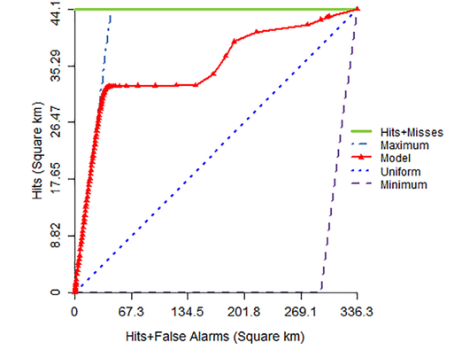

1. The authors used a model that has high predictive accuracy of change.
2. The authors should increase the lower transition potential values.
3. The authors probably failed to mask the pixels that were already built at the start of the simulation.
4. If the modelers would have simulated change randomly, then the model would have had a larger AUC of the TOC.

35. Should creating models with high predictive accuracy be the primary goal of land change modellers?

1. Yes, because higher predictive accuracy will help to manage landscapes better, such as conserving carbon and biodiversity.
2. Yes, because we need to know what the future will be.
3. No, because higher predictive accuracy is not necessary to use a model to gain insights on how to make land-use decisions.
4. No, because it is impossible to predict the future.

Essay

Organize your response into the three subsections A, B, and C listed below. Each subsection is worth 10% of exam grade. The maximum number of words is **900** for the sum of the subsections. Write in full sentences that are organized in structured paragraphs. Proper grammar and spelling are important so use a Spelling & Grammar tool. Strong responses will refer to the readings in the course.

The profession is confused concerning which simulation model to use for projects to Reduce Emissions due to Deforestation and forest Degradation (REDD). Therefore, a group of authors write a journal article that compares TerrSet’s Land Change Modeler (LCM) with Geomod. The authors use annual data from MapBiomas during 2000-2020 to apply both models to a Brazilian state. The authors report that their Figure of Merit and Area Under the TOC curve is larger for LCM than for Geomod thus they conclude that REDD modellers should use LCM rather than Geomod. How helpful to the profession is the authors’ approach? What praise and/or criticism do you have for the authors concerning their methods of analysis and subsequent recommendation? Organise your response in the following subsections labelled A, B, and C, where each subsection discusses the role of the concepts below.

1. Model features, verification, sensitivity analysis, fitting algorithms.
2. Pattern, process, stationarity, quantity, allocation.
3. Validation metrics such as Figure of Merit and AUC of TOC for applications to REDD.